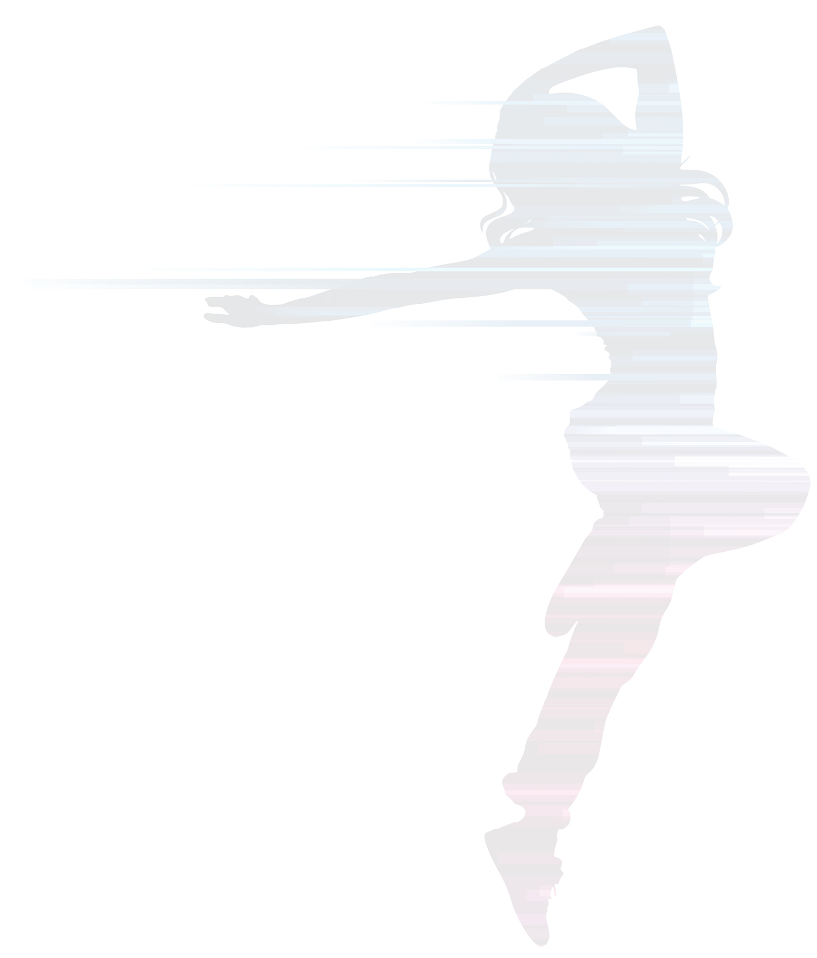
FRIDAY FITNESS CLASSES - YOU CHOOSE!

Let us know which Friday classes you would be interested in attending between now and the summer holidays, 6.30-7.15pm:

- FREESTYLE FITNESS YOGA - is a blend of ancient Yoga-inspired postures with modern fitness methods. There is no dogma, chanting or use of Sanskrit terms. The focus is on strength, stability, suppleness, mindful breathing and you will feel fantastic afterwards! (Please tick) ☐
- POWERSTEP ‘COMBO’ - Power Step is for you if you want toned thighs and a firm smooth butt!!Back to basic moves and combinations with the focus on effectiveness, form and fun! For lovers of original step. (Please tick) ☐
- BEACH BODY WORKOUT - Get your ‘Baywatch’ body ready for the beach and holiday season. A fun whole body workout designed to tone wobbly bits, define muscle and improve your fitness ready for the slow motion run across the beach into the sea!“ Eat your heart out Hoff and Pamela!” (Please tick) ☐
- BIG BALLS AND WHAT TO DO WITH THEM - Used by Physiotherapists for many years, Stability Balls are an excellent training tool for rehabilitation, ante/post natal exercise, full body and core training workouts. Used by Olympic athletes and patients recovering from injury. Learn how to use them safely and with maximum effect. (Please tick) ☐
- ANY OTHER SUGGESTIONS?
Please write your suggestions here:
_______________________________________________________________
_______________________________________________________________
_______________________________________________________________
_____________________________________________________Thank you!
Name _________________________ Telephone ___________________________
Email _______________________________________________________________
FRIDAY FITNESS CLASSES - YOU CHOOSE!

Let us know which Friday classes you would be interested in attending between now and the summer holidays, 6.30-7.15pm:

- FREESTYLE FITNESS YOGA - is a blend of ancient Yoga-inspired postures with modern fitness methods. There is no dogma, chanting or use of Sanskrit terms. The focus is on strength, stability, suppleness, mindful breathing and you will feel fantastic afterwards! (Please tick) ☐
- POWERSTEP ‘COMBO’ - Power Step is for you if you want toned thighs and a firm smooth butt!!Back to basic moves and combinations with the focus on effectiveness, form and fun! For lovers of original step. (Please tick) ☐
- BEACH BODY WORKOUT - Get your ‘Baywatch’ body ready for the beach and holiday season. A fun whole body workout designed to tone wobbly bits, define muscle and improve your fitness ready for the slow motion run across the beach into the sea!“ Eat your heart out Hoff and Pamela!” (Please tick) ☐
- BIG BALLS AND WHAT TO DO WITH THEM - Used by Physiotherapists for many years, Stability Balls are an excellent training tool for rehabilitation, ante/post natal exercise, full body and core training workouts. Used by Olympic athletes and patients recovering from injury. Learn how to use them safely and with maximum effect. (Please tick) ☐
- ANY OTHER SUGGESTIONS?
Please write your suggestions here:
_______________________________________________________________
_______________________________________________________________
_______________________________________________________________
_____________________________________________________Thank you!
Name _________________________ Telephone ___________________________
Email _______________________________________________________________
info@dybo.co.uk •   • www.dybo.co.uk
info@dybo.co.uk •   • www.dybo.co.uk

